DIY Projects:

Using the ICS612 CLICK PLC for roasting coffee

Abstract

Hands-on activity is one of the best ways to reinforce learning. Similarly, building out home ICS labs is a great way to keep knowledge current, and in many ways, explore new ideas or topics and increase skill sets, all while having a bit of fun in the process. Because ICS systems manipulate the physical world, they can be more challenging when building DIY home projects due to the cost and complexity of the equipment. A great way to start these projects is to use student kits provided by ICS courses as a building block to develop home automation kits and labs. This paper documents one such example through the process of leveraging the CLICK PLC and C-more HMI, used in the ICS612 SANS course, and leveraging additional components to automate the process of roasting coffee.

# Introduction

Home ICS security labs and automation projects provide the perfect opportunity to take learnings from ICS courses or job experiences and develop a solution that helps solve a physical world problem. Figuring out what to solve is often the real challenge. When interfacing with the physical world, the principles of engineering take play. Bits and bytes drive real equipment that may be used for controlling temperature, for example. Converting outputs from Raspberry PI systems or Programmable Logic Controllers (PLC) to drive fans and heaters pose real-world challenges that are often the remit of automation and electrical engineers. Wiring these components up is often the remit of Instrumentation and Electrical Technicians. Therefore, when implementing home automation projects, one plays the role of programmer, ICS security lead, automation engineer, and field technician.

Choosing what to control and automate is the first step: choosing how is much more complicated. Often there is some iteration between these two stages. Some areas that appear interesting on the surface could be cost-prohibitive, or the infrastructure and utilities at a residence may not provide the necessary power, water, heating, or cooling requirements. Therefore, scope and scale may need modification before going into the detailed engineering and programming phase of the project. This is very similar to project management, where a detailed project charter is developed, and the project is further described, and scope, schedule, costs, and procurement worked throughout the project ­ — with many adjustments along the way.

For the coffee roasting project, two main requirements would be incorporated. The first was to utilize the CLICK PLC and C-more Human Machine Interface (HMI) from the SANS ICS612 course. The second requirement was to leverage a working manual coffee roaster. Automating the roasting process leveraging the two main requirements was the third. With those requirements outlined, it was time to do detailed engineering work to procure components necessary for the control cabinet and coffee roaster.

# Coffee Roaster

The first task for the coffee roaster project was to procure a manually controlled coffee roaster that could be retrofitted with an external heat controller and include a fan that could be controlled by an external motor controller. After spending time researching coffee roasters and reading reviews, the Fresh Roast SR540 from Home Roasting Supplies was chosen as a good fit. As shown in Figure 1, the SR540 is small, uses a 15-amp, 120-Volt AC house power circuit, boasts a simple heater and fan, and provides dark roasting times near 10 minutes.

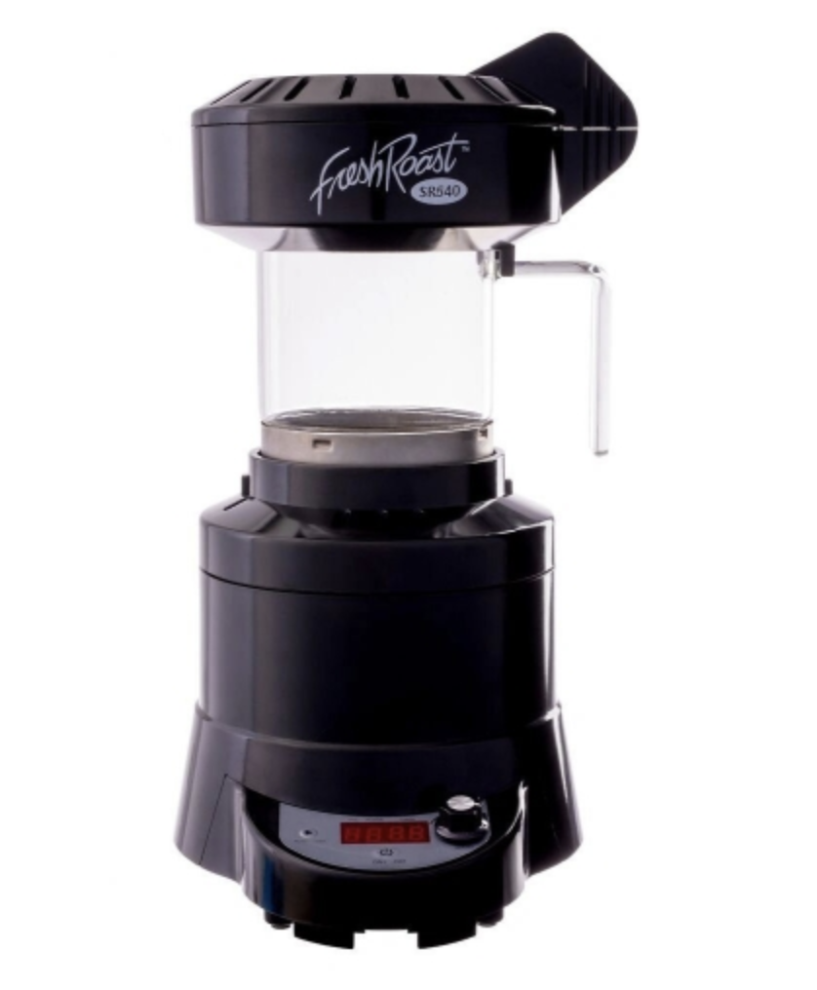

Figure 1. Fresh Roast SR540 Coffee Roaster (Home Roasting Supplies, n.d.)

Fresh Roast also produces the SR800 roster that can handle much more coffee beans per roast, but that model requires a 20-amp electrical circuit alone. With the control equipment taking more than 2 amps itself, there needed to be some headroom ampacity left or circuit breakers would have been tripping during the roasting process, which would not have been advantageous.

Upon receiving the roaster, the first task was to take voltage and current measurements to determine the component size needed for the AC solid-state relay, which is used for heater control, DC motor drive, and DC power supply, as shown in Figure 2.

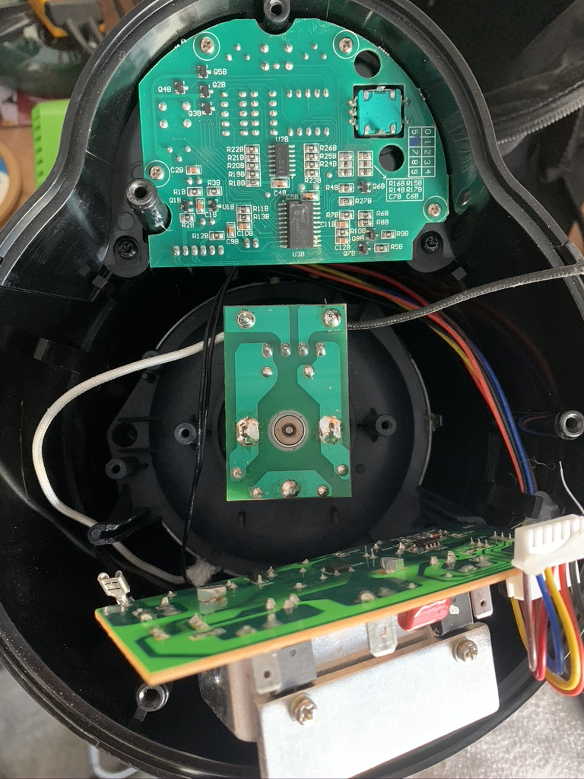

*Figure 2.* Fresh Roast SR540 circuits exposed for measurement

With measurements made, the next step was to remove the heater controls and AC to DC motor circuit board that is soldered to the on the Fan motor. For some, this is a difficult step of rending a working device temporarily inoperable and completely void the warranty. With those components removed, two electrical cords (one for DC fan and one for the AC Heater) were soldered to the roaster, as shown in Figure 3. The extension cables used different style non-interchangeable electrical connectors to disconnect the roaster from the controller cabinet, should they need to be moved or separated.

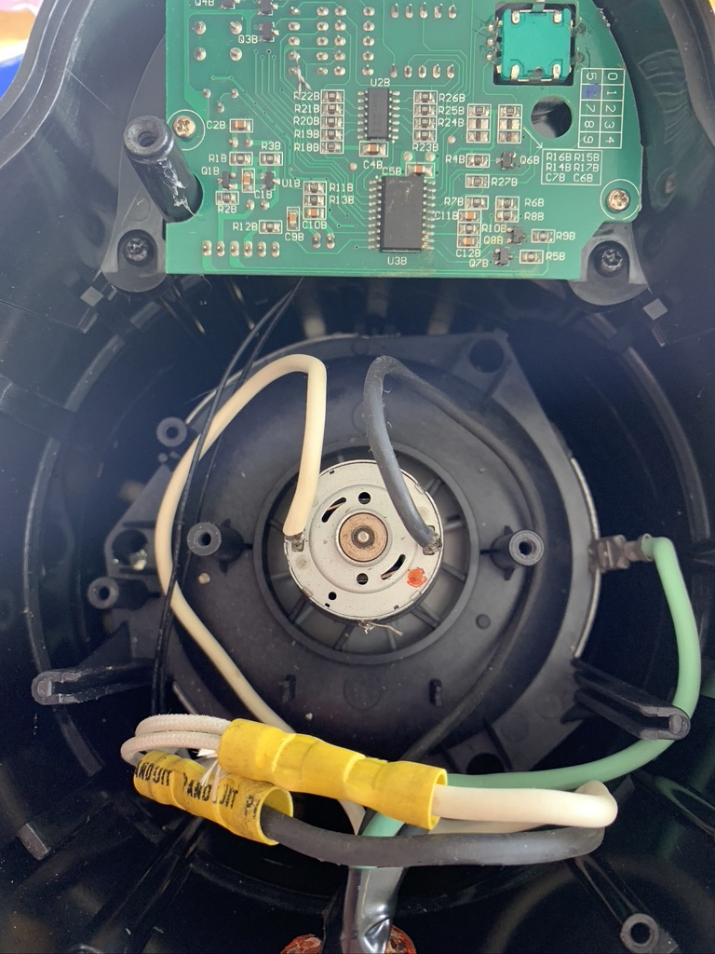

DC connection for Roaster Fan

AC connection for Roaster Heater

*Figure 3.* Fresh Roast SR540 with wiring modifications made

The last modification to the roaster was made to measure the temperature of the coffee beans (the controlled variable), which would later be used as an input to the temperature control scheme. This modification included drilling a small hole the roaster cap to allow a thermocouple to protrude down into the coffee beans, which is the critical temperature to measure during the roast process. Although the ICS612 student kit comes with a ¼” type K thermocouple, this was later found to be too slow in response to temperature for adequate control. Therefore, an 1/8” thermocouple was later procured and installed. The final installation is shown in Figure 4.

1/8” hole drilled for Thermocouple

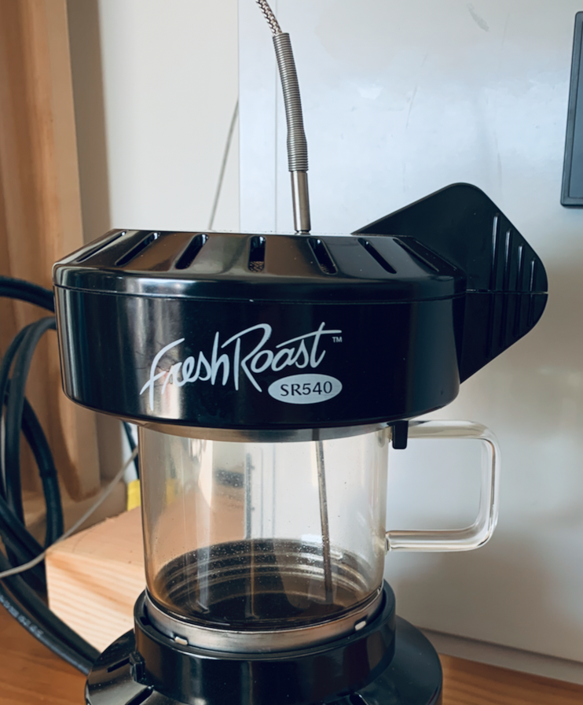

Thermocouple tip located in coffee bean mass

*Figure 4.* Fresh Roast SR540 with 1/8” thermocouple addition

With the roaster modifications complete, it was time to research and purchase the equipment needed for temperature and fan control and provide a control box to house all components.

# Control Cabinet Components

The original requirements starting was to leverage the CLICK PLC provided in the ICS612 course as a base for controlling coffee roaster temperature and fan speed. The PLC that came in the 2019 ICS612 course student kit leveraged an Ethernet PLC module with discrete I/O capability and a Thermocouple card. It also came with a discrete low voltage (3.5 volts DC), as shown in Figure 5.

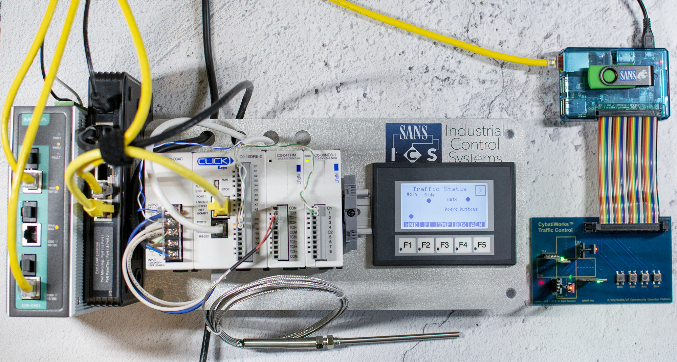

*Figure 5.* ICS612 beta class version CLICK PLC

The Click PLC is a product of Automation Direct, which sells lots of automation components. To keep the bill of materials for this project down to a minimum number of vendors, Automation Direct was the primary source for parts and supplies. However, this is not promoting Automation Direct. There are other vendors to choose from when working on these projects. Nevertheless, it is helpful to reduce suppliers to a minimum for order tracking and integration support between products from the vendor should it be required.

For the roasting application, the requirements for controlling temperature and fan speed necessitated additional input/output modules for the CLICK PLC to control the solid-state relay, which would ultimately control the temperature in the roaster. Therefore, a CLICK digital output module C0-08TD2 was selected. The overall temperature control logic would leverage a pulse width output to vary the time on versus the time off to control heat. Although this can be done with the internal relay output in the PLC CPU module, the relay would quickly fail due to the duty cycle limitations of mechanical devices. Therefore, a solid-state option is needed, which required an additional I/O card. The Solid-State Relay (SSR) model number AD-SSR625-DC-280A, was chosen for the solution as it provided 3-32 VDC input control voltage and could drive a 25A 24-280 VAC load voltage. The SSR was slightly oversized allow for the SR800 coffee roaster current draw should a future upgrade occur to replace the SR540.

The roaster fan required variable control to adjust airflow during the roasting process, but before the analog output card could be selected, a DC motor drive needed to be selected, which would determine the required type of input to the drive or, conversely, the output from the CLICK PLC module. After some internet research, the Iron Horse GSDA-148-10C DC drive was selected for the application. The particular model allowed remote analog input capability from a PLC, provided the necessary range for fan speed control, and had the capability for larger fan motors for future upgrades down the road. Usually, analog outputs from PLCs use 4-20ma signals, which 4ma represents 0%, and 20ma represents 100% output. However, the DC motor drive required a 0-10 VDC input signal. With that requirement, a CLICK PLC output card C0-04DA-2 was selected as it provided the required 0-10 VDC output signals. With that module, the PLC hardware configuration was complete, as shown in Figure 6.

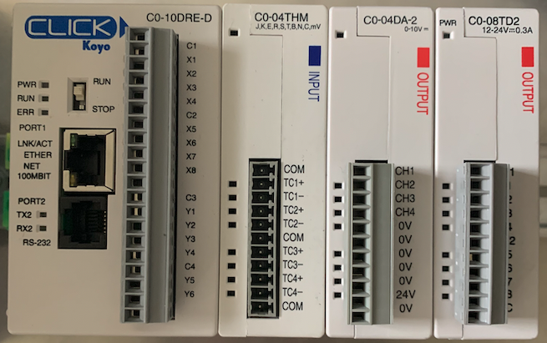

*Figure 6.* CLICK PLC with digital and analog output modules

With a DC Motor drive selected, a DC power supply could now also be researched and selected to provide the adequate current range and also provide the headroom for powering additional 24 VDC components and for a larger roaster should the need arise. The RHINO switching 24VDC power supply, model PSP24-240S, matched the requirements for the project and provided almost 50% additional headroom for any further expansion. For those looking to reduce the cost of this build, purchasing a smaller power supply would be one area. However, a smaller 5-amp 24VDC power supply would be near full capacity.

A good rule of thumb is to allow for 20% additional capacity when determining components. Before going much further in the process of procuring the components, however, an overview drawing was needed to identify the components and begin to understand how they would be laid out in the control panel. With control panels, AC and DC interference needs to be kept at a minimum, and there are also potential heating issues with minimum manufacture recommended clearances between devices. Also, wiring has to be connected somewhere on terminal blocks. Therefore, before a control panel size was chosen, the documentation for each vendor component was reviewed to determine spacing requirements. From these requirements, the components layout was templated to accommodate for heat dissipation and separation of AC and DC circuits, as shown in Figure 7.

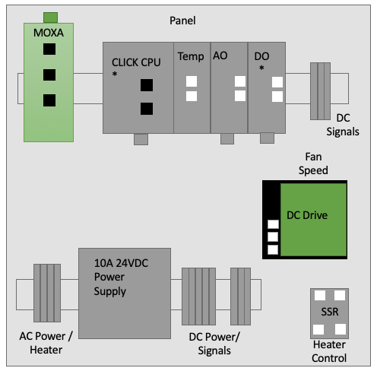

*Figure 7.* Proposed component layout in the roaster control panel

With the proposed layout in place, an AttaBox Freedom series enclosure with a measurement of 18in x 16in x 10in (HxWxD) was selected to accommodate all components. The associated 18in x 16in subpanel for the enclosure was also selected to mount the equipment. To mount the components to the subpanel, such as the terminal blocks, PLC, MOXA, and power supply, a DIN rail, slotted, 35mm, 10mm height was used. The terminal block part numbers are included in the BOM section in the appendix. With the major components identified, an order was placed. Upon receiving the parts, they were positioned, as shown in Figure 8, which closely aligns with the overall component layout in Figure 7. With a program, such as AutoCAD, one could get the measurements exact, but that software was not used for this project.

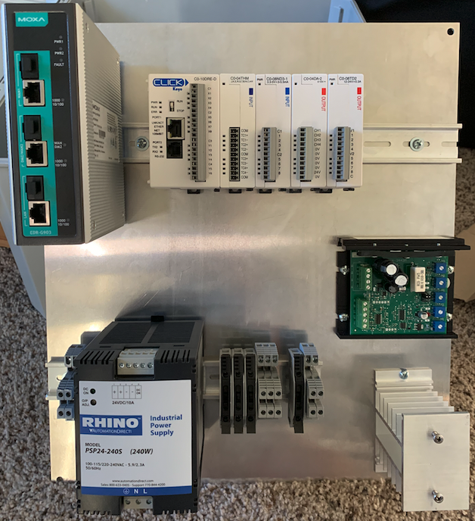

*Figure 8.* Main components mounted on the subpanel

Due to the weight of the power supply on and MOXA, the screws were “through-bolted” versus tapped into the subpanel. It is standard practice to tap the panel for screws and not install nuts on the backside of the subpanel, which helps with future modifications as one doesn’t have to take the subpanel out to remote a component. However, for small projects or when the subpanel is thin material, putting nuts on the backside is recommended. With the subpanel coming together, it was time to begin wiring the AC power and DC signals.

# Wiring

One of the primary considerations with wiring and power is ensuring safety and following local electrical codes. For those new to this topic, a quick internet search quickly reveals ampacity, temperature, and voltage constraints for a particular type and gauge of wire. The extension wire chosen for this project was 12-gauge THHN wire, which can handle a full 20-amp circuit. Internal to the panel, wiring for all 120VAC circuits was 14-gauge stranded THHN, which can handle 15-amps or above the roster amperage rating. For 24 VDC wiring, one would typically use a 16 to 18-gauge stranded “twisted pair.” Unfortunately, that wire was difficult to procure that the time of the build, so low voltage 18-gauge solid core wire was used. This is fine for home-use but would not be suitable for commercial or industrial environments with vibration, as the wire may fatigue and eventually break.

The next area to consider is wiring for each input and output (I/O) PLC card and electrical components. Here equipment manuals and wiring diagrams need to be consulted before connecting wires and energizing circuits. This is especially true with I/O cards supplying power to the circuit (called sourcing) versus measuring or controlling circuit power (called sinking). Each manufacture offers different solutions, and there is a wide variety of connection options among cards.

A recommendation is to draw out each input or output circuit before running wires. This helps with reduced rework, serves to reinforce concepts, and also helps with document creation, should it be needed in the future. Diagrams can be completed in PowerPoint, Visio, Lucidchart, or whatever program a user is comfortable with using. The first diagram is for the emergency shutdown circuit, which is used to place the roaster in cooldown mode and disable the output – all in the PLC program. The ESD circuit is connected to the CLICK PLC Processor and utilizes built-in digital inputs, as shown in Figure 9. The pushbutton is normally closed, common among ESD switches, and the switch is mounted on the front of the cabinet.

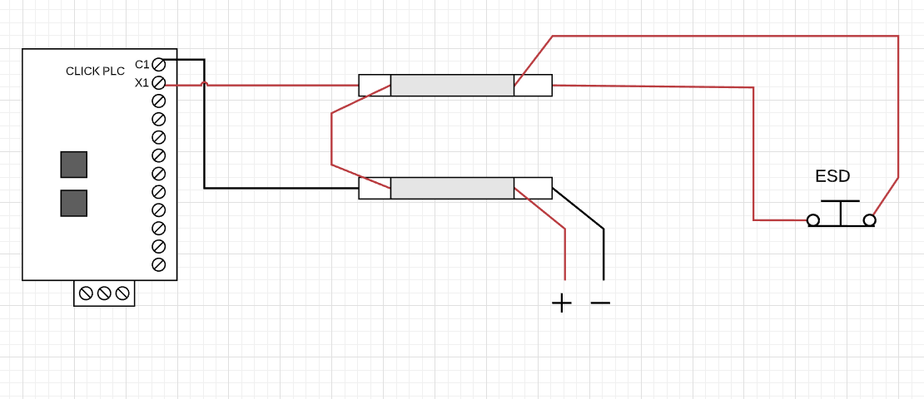

*Figure 9.* ESD circuit wiring diagram

The thermocouple input card measures the millivolt thermocouple signal and converts that to a temperature signal to be used in the PLC program. For this project, it was critical to measure not only the coffee roast temperature but also the internal panel temperature. The control panel used convection by pulling drawing heat from a lower vent hole and pushing it out through an upper vent hole, versus an active fan. Although this works for cooling, it is not as efficient as forced cooling, so the control panel temperature was measured to provide input to a temperature alarm, as shown in Figure 10.

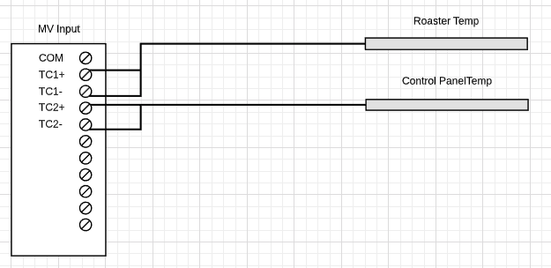

*Figure 10.* Thermocouple wiring diagram

The next circuit is for the roaster DC motor control. This diagram shows the connections from the CLICK 0-10 VDC analog out card to the IronHorse GSD1series DC drive. The DC variable frequency drive normally accepts a potentiometer input but can also use a 0-10VDC input to control motor speed. The drive, however, does not handle the first 20% of the signal, so there is a dead spot from 0 to 2 volts output from the I/O card. This was not an issue as the motor usually operates at 80 to 100% output, but it is something to be aware of. The CLICK PLC card requires 24VDC power as it sources loop power, and the DC drive also requests 24VDC as it is the source of power to the motor and can handle a full 10 amp load. The output of the DC drive is routed to a terminal block and then externally through the control panel to the roaster motor, as shown in Figure 11.

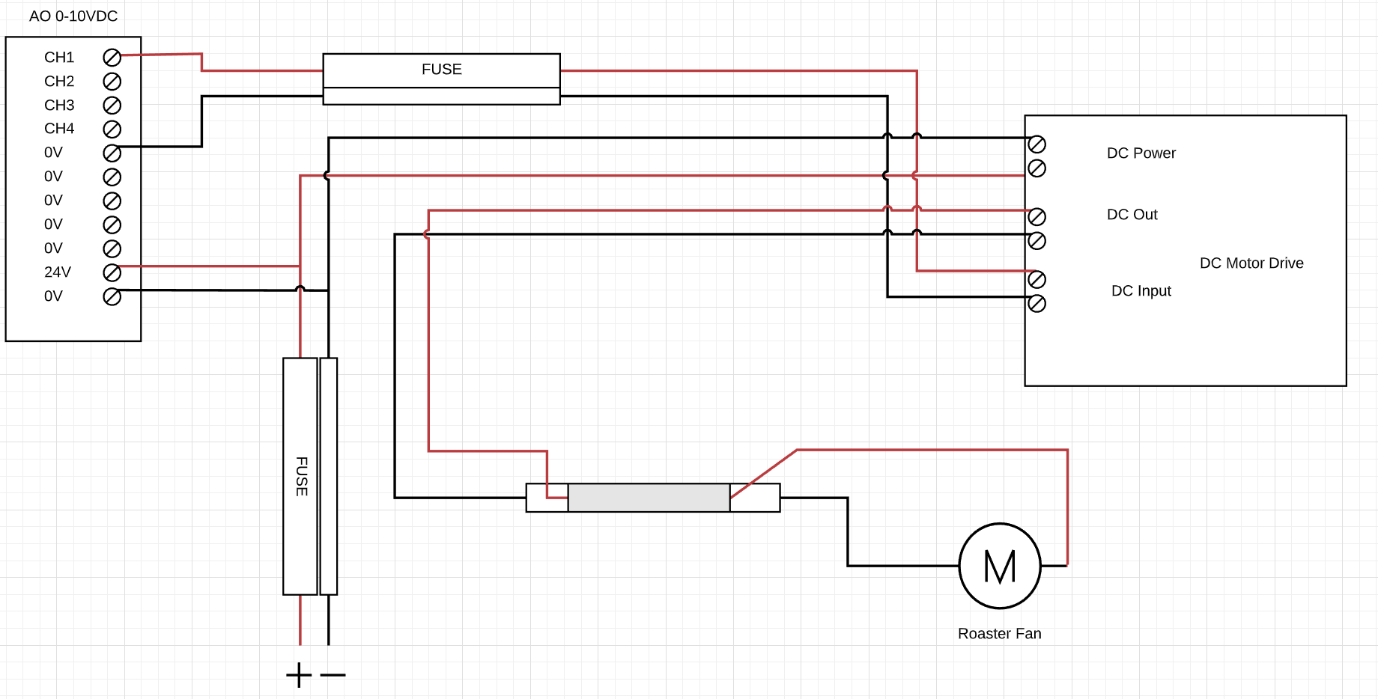

*Figure 11.* Roaster motor control diagram

The last I/O diagram is for the coffee roaster heater circuit. This circuit requires a solid-state digital output card that is used by the temperature control program as part of a pulse width modulation control scheme to turn on an external 24VDC to 120VAC solid-state relay, which drives the roaster heater circuit. The card requires 24VDC to source power to the 24 VDC control circuit, as shown in Figure 12. Again, the connection to the roaster heater is external from the control panel and utilizes a 12-gauge extension cable the connection.

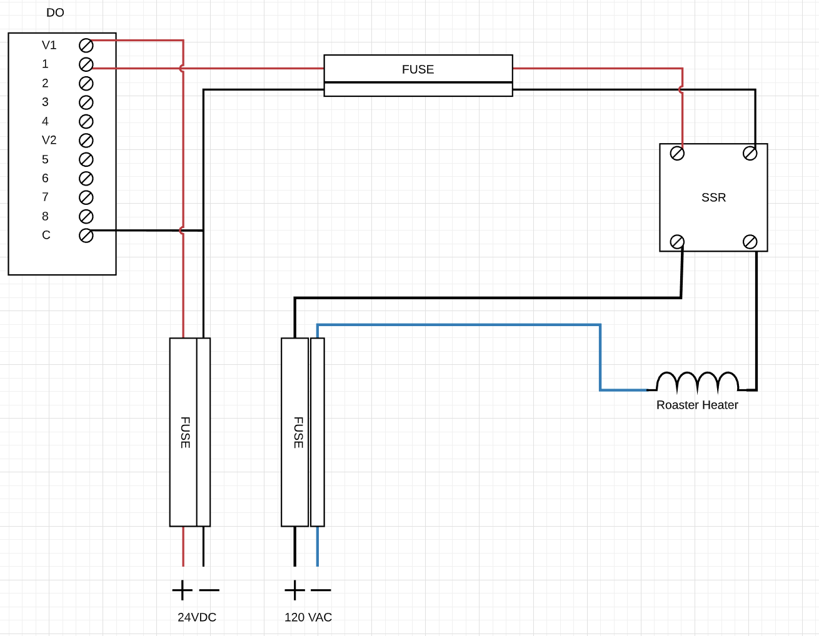

*Figure 12.* Roaster heater control diagram

The complete control panel wiring diagram is shown in the appendix and combines both 24VDC and 120VAC circuits as well as provides an example of the physical layout. Shown in Figure 13, however, is the subpanel with most of the wiring complete. Wiring a subpanel before placing it into the control panel is much preferred since all components are open and not recessed inside an enclosure. Again, separation of DC and AC circuits is essential due to safety and electrical interference reduction. An individual can use Panduit type products to keep the wiring contained, or as this project used, sticky back ties to fasten the wiring to the subpanel to keep wires in place for physical routing.

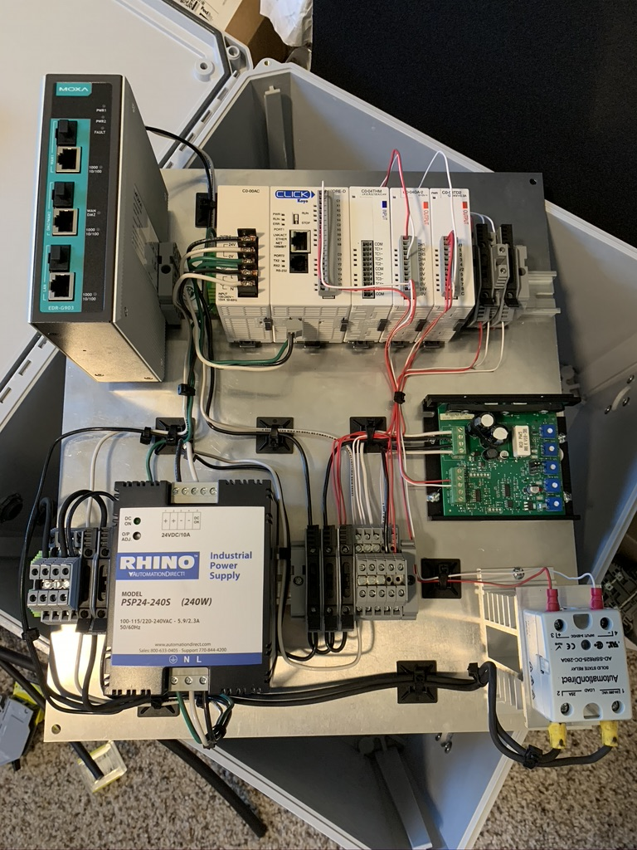

*Figure 13.* Subpanel wiring near complete

With wiring nearing complete, it was now time to begin to consider the programming aspect of the project. The two often go hand-in-hand because the I/O links to memory registers in the PLC, so part of ensuring the programming is correct is to ensure the mapping between the software and hardware is done.

# Programming

Developing the actual program can often feel a daunting task and is similar to writers’ block when looking at a blank sheet of paper and trying to figure out how to begin. One way to consider starting the process is to compartmentalize the program into logical chunks of code. For PLC programs, this often correlates to initialization, inputs, outputs, alarms, communication, and the main automation tasks. As shown in Figure 14, this is how the coffee roaster program is divided into the CLICK PLC.

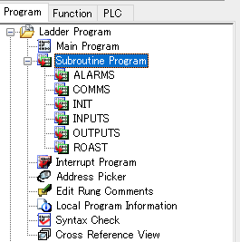

*Figure 14.* CLICK PLC program structure overview

With the program structured into logical groups, the next area is to develop the control narrative. This can also come from process requirements for the program, such as multiple roast levels (light, medium, dark), multiple temperature ramp setpoints, closed-loop temperature control, cooling, and emergency shutdown. Before getting into this detail, however, one truly needs to understand the process. For coffee roasting, in particular, there are lots of online resources to understand the roast curves and temperature profiles. One example is shown in Figure 15 and provides the time, temperature, and bean roast/colorization charts, which can be used to build ramp profiles in the PLC. The example provided, however, is for a drum roaster and, thus, the temperatures needed to be modified for the air roaster, such as the Fresh Roast SR540.

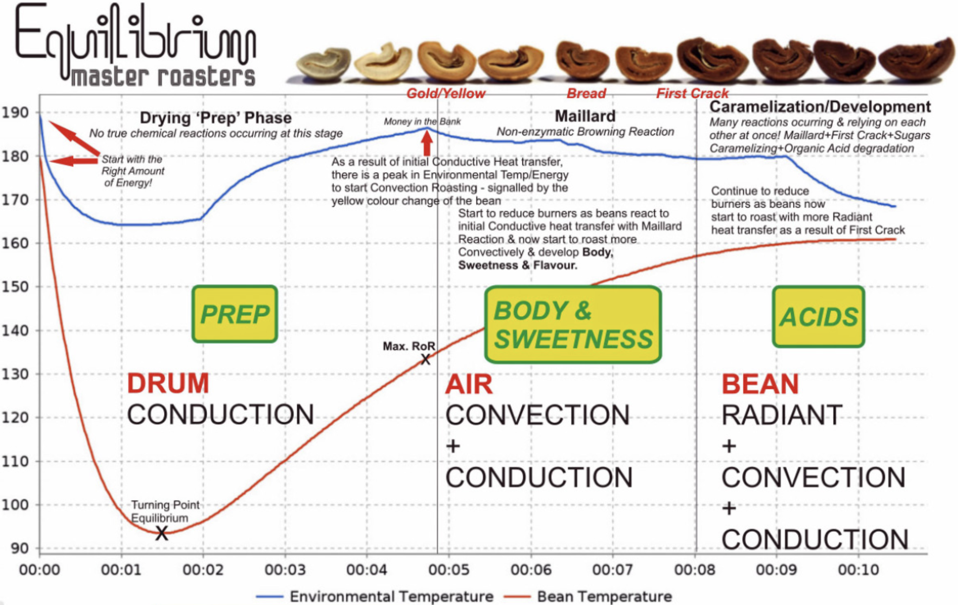

*Figure 15.* Coffee roast overview (Cooper, n.d.)

With an idea of how the roast process should take place, the next step is to develop a high-level program that can be later merged to PLC code. It is helpful to develop pseudo code before getting into detailed programming as it provides clarity on what is known and perhaps identifies areas that may need further exploration. The below pseudocode outlines the initial overview of the PLC roast program logic flow.

#Roast Time: Part of the roast profile

#Roast Temperature: Controlled by the PID loop and included in the roast profile

#Roast Fan Speed: Included in the roast profile

#Same ladder logic program for multiple roast levels

#Roast time, temperature, and fan speed setpoints saved in registers

#Program selection through HMI:

Manual 0

Light 1

Medium 2

Dark 3

When not in run mode, select the following:

Manual 0: User must input roast time, temp, and fan

* Requires min / max values

Or select program(s) 1, 2, 3

Copy roast program values into running values on control type change

Program Start (from HMI)

Start the roast timer (timer time from the roast program)

#Dark roast example

#Set initial temp and fan settings

Time_0 = 0

Temp_0 = (Dark Program ~ 250 Deg F)

Fan_0 = (Dark Program ~ 100%)

#Set drying phase

Time_1 = (Dark Program ~ 60 sec)

Temp_1 = (Dark Program ~ 350 Deg F)

FAN_1 = (Dark Program ~ 100%)

#Heat to first crack

Time_2 = (Dark Program ~ 150 sec)

Temp_2 = (Dark Program ~ 420 Deg F)

Fan_2 = (Dark Program ~ 90%)

#Heat to second crack

Time_3 = (Dark Program ~ 280 sec)

SP_Temp_3 = (Dark Program ~ 460 Deg F)

SP_Fan_3 = (Dark Program ~ 90%)

#Cooling

Time_4 = (Dark Program ~530 seconds, but can be manually activated

through the HMI)

Cooling time = 300 sec or probe temp less than 80 Deg F

Temp SP = 0

FAN = 100%

#Cooling complete

Fan = 0%

With the high-level flow of the roast program complete, the next task is to convert that into a PLC program. The CLICK PLC uses ladder logic predominantly for programming and is described going forward. However, if a user has a PLC that can utilize other languages, such as structure text or sequential flow charts, both could be used in this application. However, the program is not reviewed in full as it can be downloaded from the link in the appendix and reviewed. Nevertheless, the significant components are to be discussed. As shown in Figure 16, if the roast program is not running, the range of selected program is in the correct range, and the roast is not cooling, copy the selected program value, which is input from the HMI.

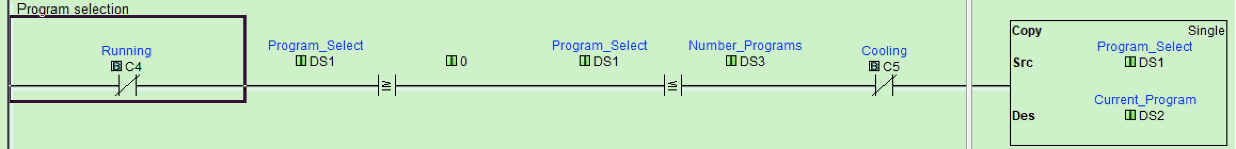

*Figure 16.* Initial PLC logic for program select

The current program value is then checked against multiple math statements to verify it matches one of the pre-defined coffee roast program values. As shown in Figure 17, a match is made for current program 3, which is the dark roast program. When that rung is logically true, the copy block executes once. Note the square wave symbol in the block. This means that this is a “One Shot” copy or only copy once. Normally if a rung is true, the output command executes every PLC scan cycle. For those unfamiliar with some of these programming constructs, a recommended reading is *Learning RSLogix 5000 Programming* (Scott, 2020).

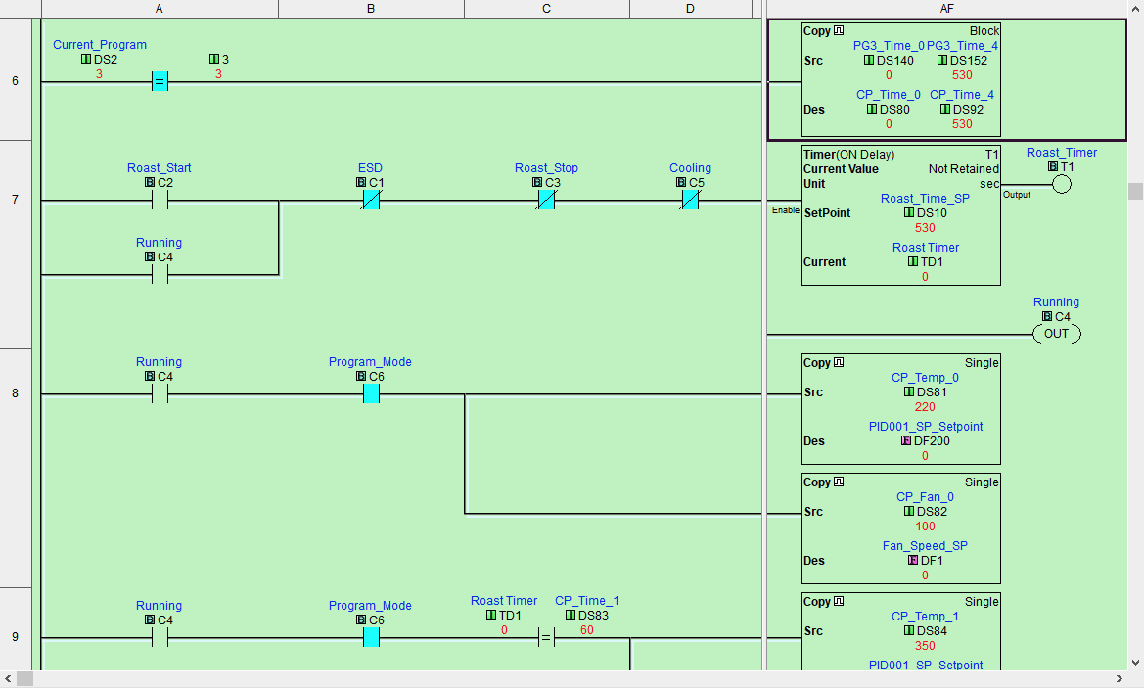

*Figure 17.* “One shot” copy statement to move program register values

The registers used for the roast profile in the PLC are laid out in series for ease of program manipulation. The copy block is copying a range of values starting at DS140 to DS152 and placing them in the destination register DS80 through DS92. This allows for ladder logic code recuse but dynamically changing program values in the ladder logic depending on which roast is selected. As shown in Figure 18, the dark roast values are preset. These values were determined initially from external research and then from making multiple roasts for desired taste.

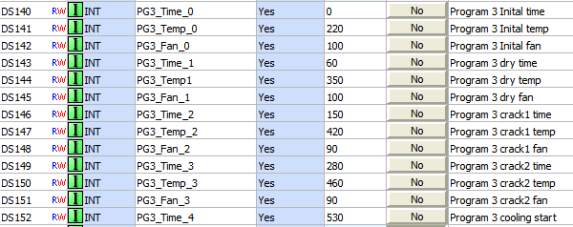

*Figure 18.* Program 3 (Dark Roast) preset values

With the roast values copied over to the current program settings, the roast process can start. Coffee roasting is a batch process on the outset with a continuous temperature control process to maintain bean temperature. Because of the batch process characteristics, time is a primary variable with consideration to roast. All things being equal, time should determine when controlled variables are manipulated, and thus a program timer drives the entire roast process. As shown in Figure 19, when a user starts the roast through an HMI, the roast timer begins to count down. The roast timer final time setting comes from the selected roast. For program 3, this is 530 seconds, which is loaded when the user selects the program.



*Figure 19.* Roast main timer logic

The roaster timer stops if the ESD button is pressed, the roast stop button is pressed, or if the program is the cooling mode. Timers only time when the input is logically true. Therefore, seal-in logic is required to keep the timer active; otherwise, when the roast start button is released from the HMI, the timer would reset. This is why the C4 Running examine-if-closed input is connected in parallel with the Roast_Start input in Figure 19 to keep the timer timing after the start button is released.

The roast timer continues timing until it reaches the timer setpoint. Throughout that time, however, the temperature and fan settings are modified, as discussed, to maintain a proper roast. As shown in Figure 20, when the time passes a given period, a new temperate and fan speed values are copied over from the current program registers to the temperature setpoint and fan speed setpoints. As the roast time increments, if it reaches a roast program set time, such as on rung 9 or 60 seconds, it enables the run and copies the temperature value of 350 and fan value of 100 to the respective control registers. To ensure the copy only occurs once the copy blocks are configured as “one-shot” copies, so the values are only copied once per a rung true condition.

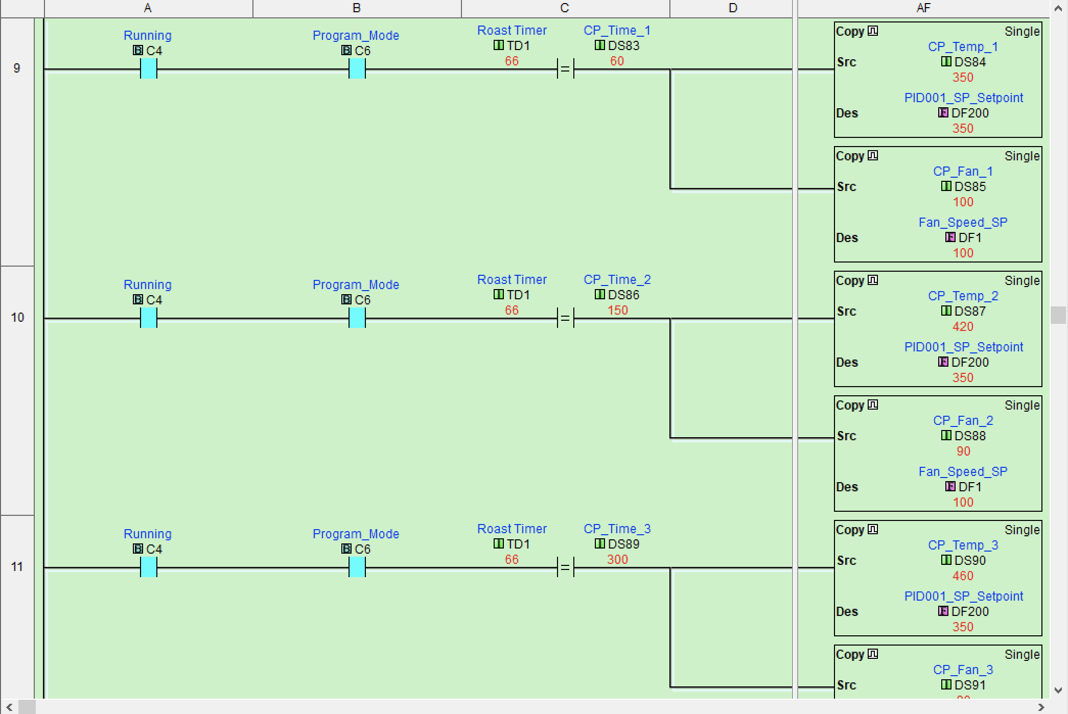

*Figure 20.* Roast temperature ramp and fan speed logic

As the program timer continues rungs, 10 and 11 are evaluated for a logical true condition. When the timer value of TD1 matches DS86 or DS 89, respectively, the associated rung temperature and fan values are copied over. When the final program timer value is reached or when a user interrupts the program through the HMI, the cooling timer logic is enabled, as shown in Figure 2,1 by the Running C4 bit configured to trigger on a True to False state change.

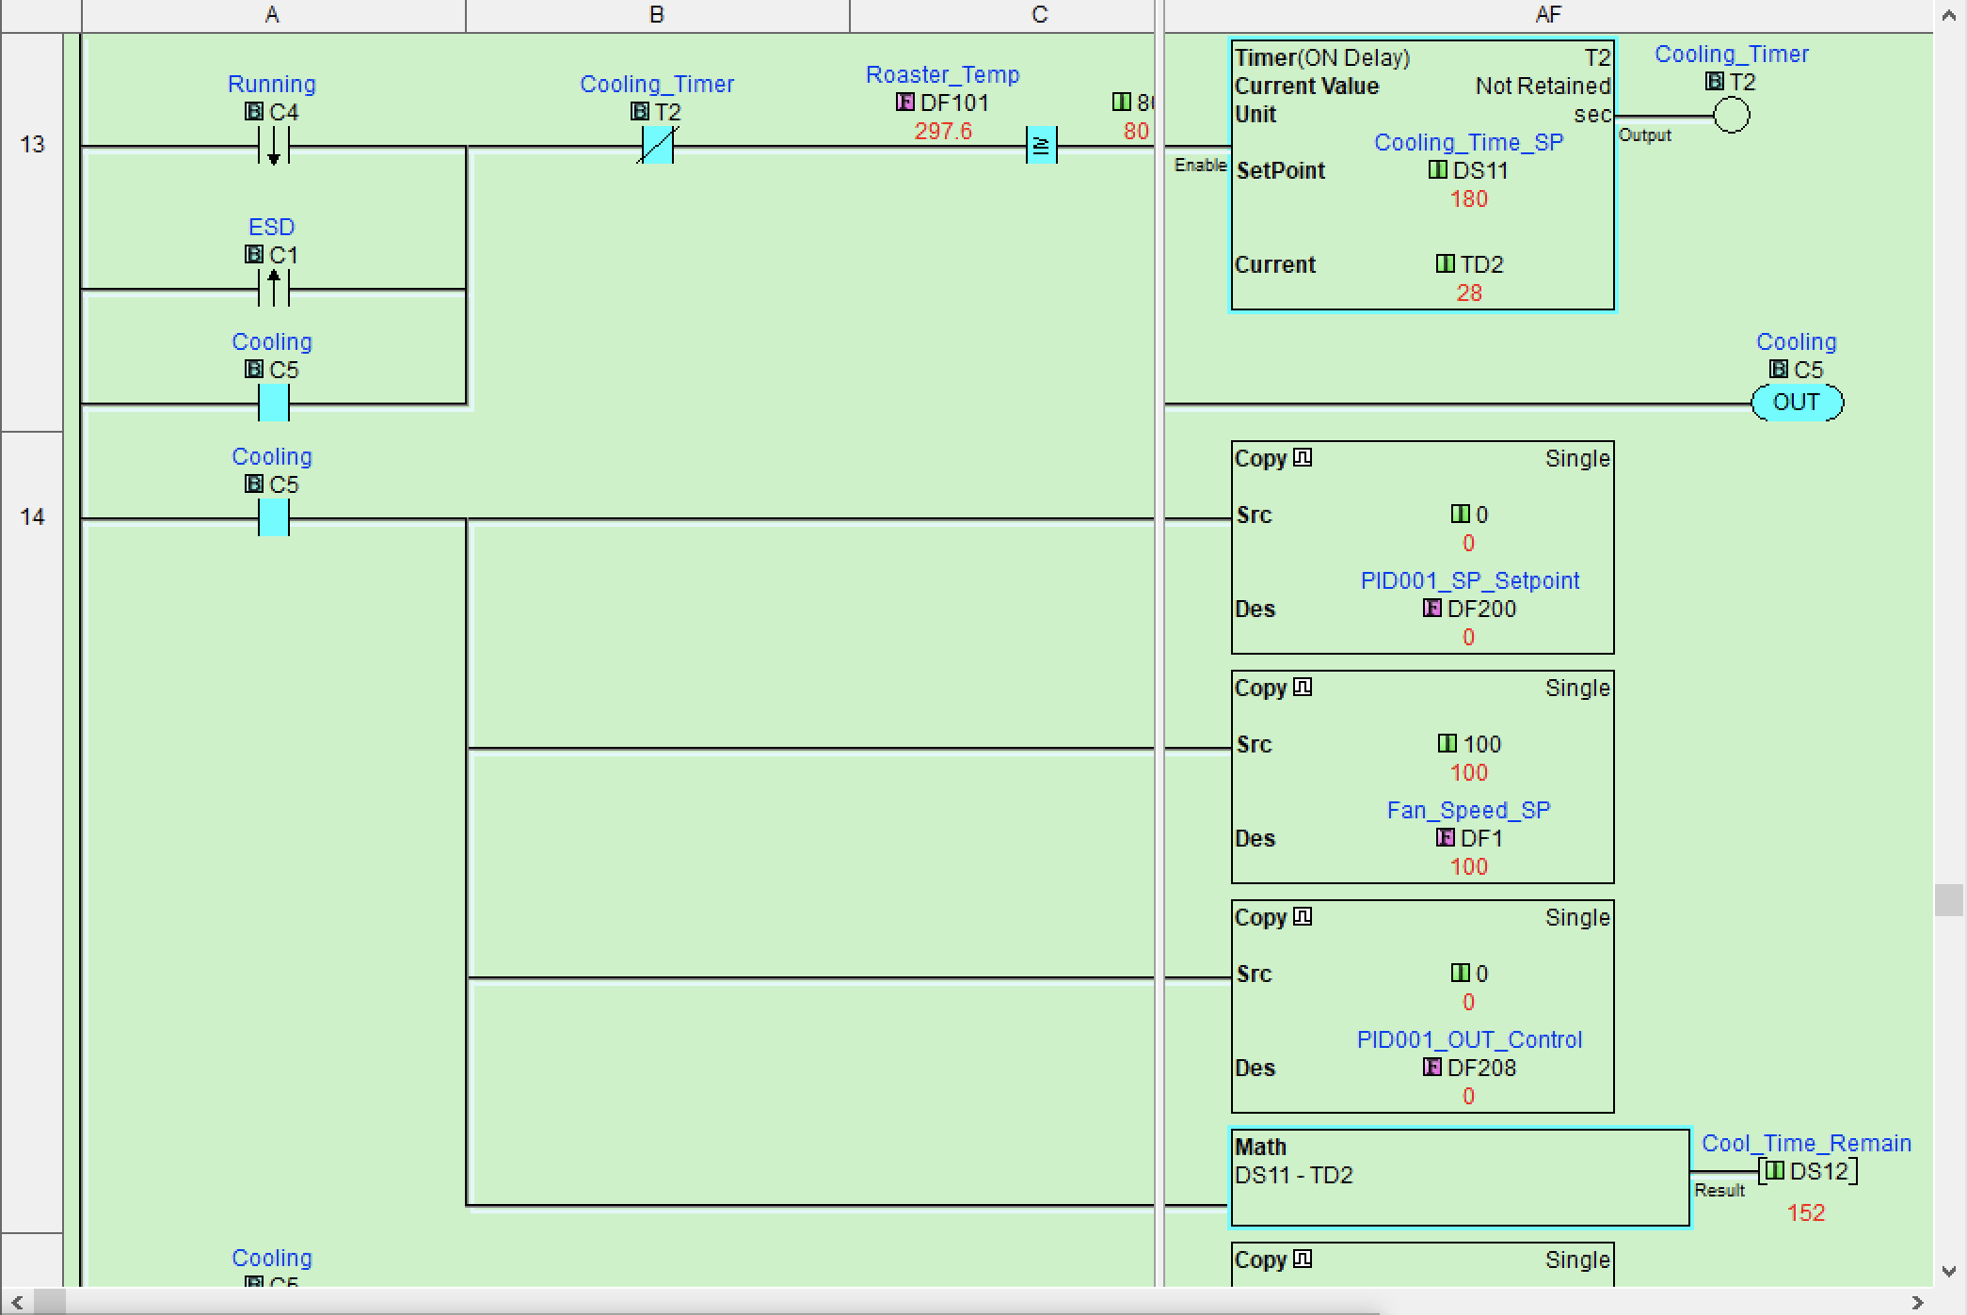

*Figure 21.* Roast cooling logic

Similar to the main roast timer, the cooling timer uses a seal-in cooling contact, C5, to keep the timer timing. The timer continues until the timer reaches the 180-second setpoint or if the bean temperature falls below 80 Deg F. When bit C5 is on, it also enables the rungs to copy the temperature of 0 to the PID temperature setpoint, sets the fan speed to 100% and forces the PID output to 0. Additionally, a Math block begins counting up, which is used as a visual indication of cooling progress for the HMI panel. When the cooling timer is finished or when the roast temperature probe reading goes below 80 Deg F the cooling bit C5 goes false, which enables a copy routine to set the fan speed to 0, as shown in Figure 22.

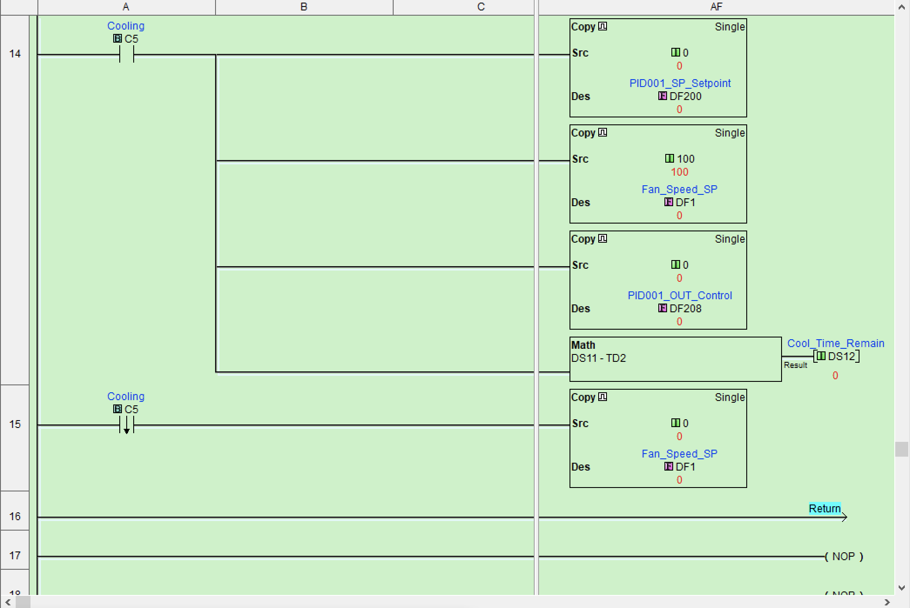

*Figure 22.* Final cooling logic

At this stage, the roast process is complete and ready for human intervention to remove the beans from the roast chamber into an external container. Let the beans rest for at least 24 hours before grinding, brewing, and consumption.

The roast routine leverages inputs for the ESD button, cabinet temperature, and roast temperature. It also sets outputs to the motor fan speed controller and, coming from the PID control loop, sets outputs to the solid-state relay. Linking inputs into the program is where the physical world of wires meets the logical world of registers. For inputs, such as temperate, the probe type and scaling must be set in the PLC to read the correct temperate in the units that are required for the application. As shown in Figure 23, the click PLC temperature card is configured for the thermocouple type K and range and is configured to place the current reading in floating-point register DF101.

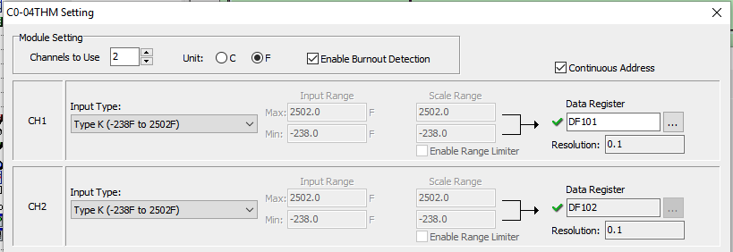

*Figure 23.* Temperature input card configuration

Temperature validation happens in the input routine to verify that the temperature is above or below a specific value. For this application, the temperature should never drop below 0 deg F or rise above 1000 Deg F. If the temperature is within the range, the value is copied over to the PID temperature block for use as an input in the control logic, shown in Figure 24.

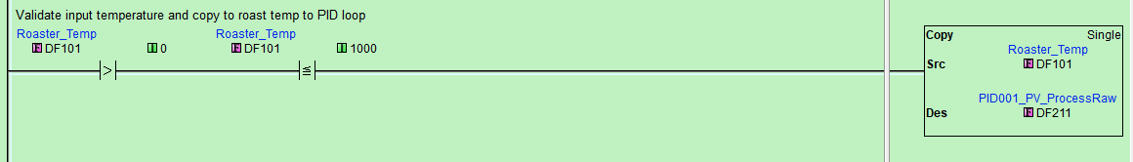

*Figure 24.* Range checking input routine

The output routine handles temperature, and fan speed is shown in Figure 25. Rung 1 shows the heating output control. The digital output only turns on if the ESD button is not depressed or if the fan speed setpoint is above 30%. This is to ensure there is airflow across the heater element before turning the power on to prevent an unsafe condition and heater element burn-out. Rung 2 takes care of fan speed stings and copies the fan speed setpoint to the output card register at DF150. Again, this rung is performing range checking to ensure the requested fan speed values are within an acceptable range.

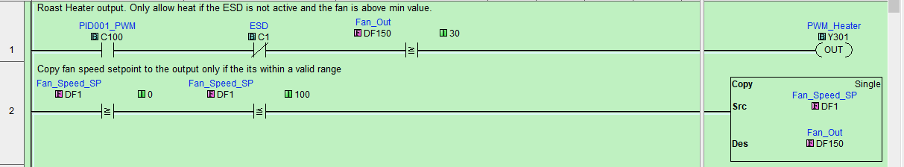

*Figure 25.* Output routine

Now that roast, input, and outputs have been described, the actual control of the temperature is performed by the PID control loop, which needs configuration. With the CLICK PLC, PID loops are configured and monitored outside of the ladder logic. Other PLCs contain PID control blocks within ladder logic, so implementations may differ depending on the manufacture. Nevertheless, the PID configuration begins with defining the name and memory address that the PID loop uses, as shown in Figure 26.

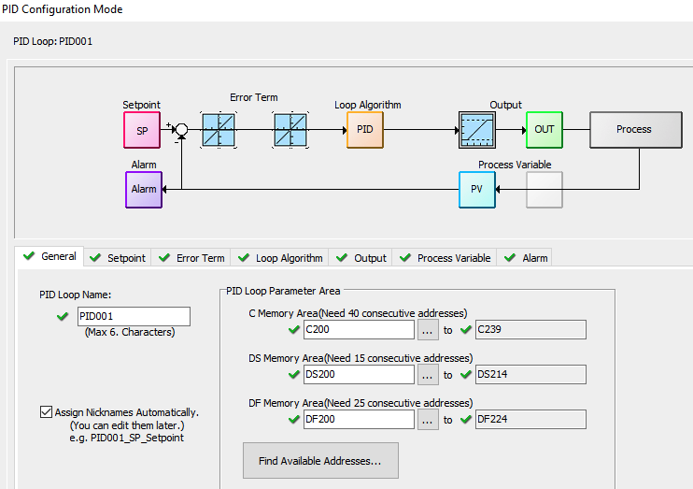

*Figure 26.* Initial PID loop configuration

Keeping a logical organization of memory addresses is essential with configuration and programming PLCs. With the PID loop configuration, it is no different. When choosing addresses and ranges, it is good to plan for change during the immediate programming stage and future projects. Therefore, the addresses have been chosen to allow for additional PID loops should they be required at a later date.

The next tab in the PID configuration is used to establish the Setpoint and ranges. The memory values used for the setpoint are within the ranges chosen on the general tab. As shown in Figure 27, the temperate setpoint register is DF200, and limits for control have been selected to ensure the PID loop only receives setpoints within the operating envelope. This register is the same one that the roast program writes to ramp up the programmed temperature.

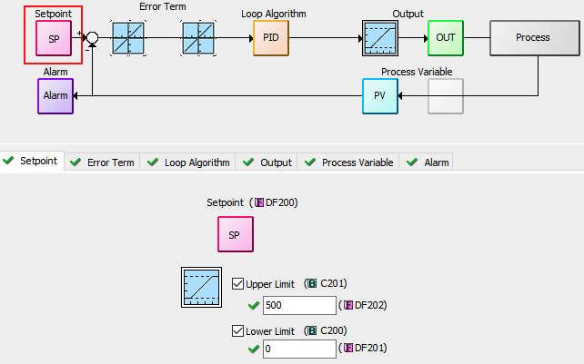

*Figure 27.* PID setpoint configuration

The Error Term configuration tab allows non-linear processes to be configured, such as pH control, and is not be discussed. The Loop Algorithm tab, however, provides the main configuration options for the PID loop and is shown in Figure 28. Here settings for the Proportional Gain, Reset Time, and Derivate Gain can be set manually or from running an auto-tune routine. Additionally, the action of the loop – direct or reverse – can also be configured in this tab. The interpretation of some of these settings differs among manufactures, so it is wise to consult the internal help documentation before configuring these settings. Specifically, the loop Action in the CLICK is opposite from many other automation vendors.

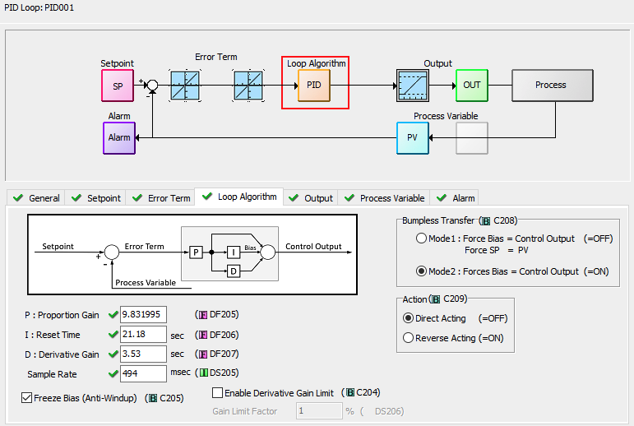

*Figure 28.* PID Loop Algorithm configuration

The output tab is where the PID output is configured and provides the ability to set ranges and the type of control. Shown in Figure 29, the output limits of 0 and 100 respectively are set. Additionally, the PWM (Pulse Width Modulation) checkbox is checked to tell the PLC that the output is used to drive a solid-state relay for a heating application. Instead of sending an output from 0 to 100 percent to drive a control valve, for example, the PWM option takes the period and divides up the percentage output from the PID loop to determine how long the output is being turned on. For instance, if the PID loop output is 25% and the Period for the block is 1 second, the output bit is enabled for 250 milliseconds. If the output is at 70%, the output bit is on for 700 milliseconds for each second. This timing directly affects the voltage going to the heater element, which affects how much heat it produces.

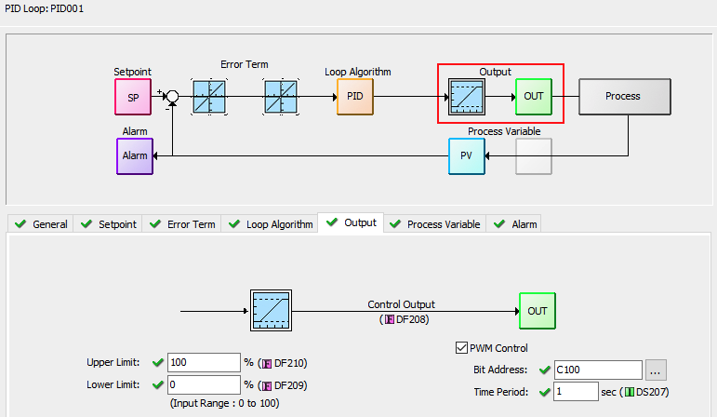

*Figure 29.* PID Loop Algorithm configuration

As shown in Figure 30, the process variable tab maps the Raw process variable register and provides the option of filtering as a way to dampen the value if the process contains high frequencies that could cause the controller to overcompensate. This configuration section also allows the user to place limits on the upper and lower values, such as those configured.

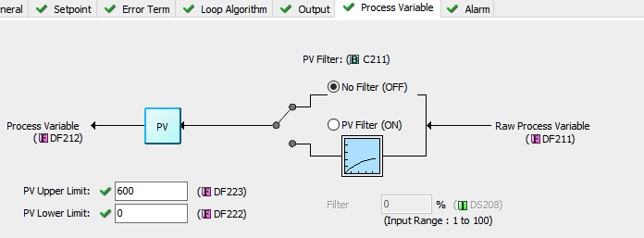

*Figure 30.* PID Process Variable configuration

With logic developed, input and output cards configured, and the PID loop configured, the final step is to tune the control loop and then optimize roast time, temperature, and fan speed settings for taste. The procedure for tunning the PID loop is contained in the CLICK PLC help documentation. With proper tuning values entered, the result operation can be seen in Figure 31.

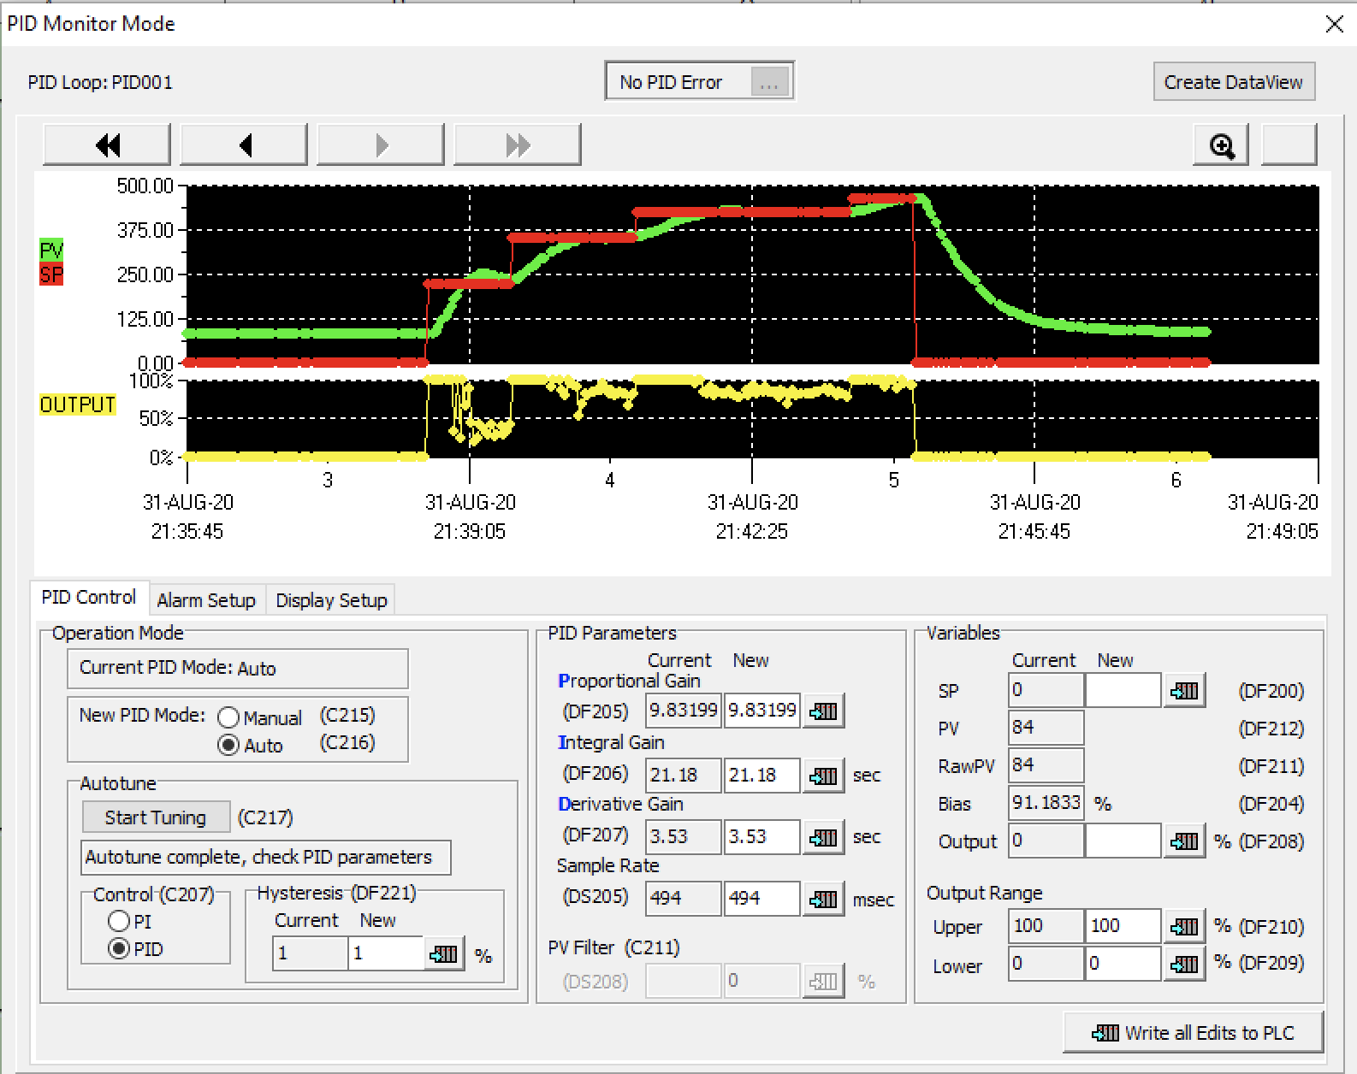

Stop Roast:

From HMI

Start Roast: From HMI

*Figure 31.* Coffee roast viewed through the PID Monitor tool

When the roast starts, the setpoint, in red, moves to 250 deg F; due to the offset between the temperate and setpoint, the controller output turns on and increases the temperature. This ramp function continues to occur at each roast stage, as outline in the roast ladder logic described earlier, with the setpoint dropping to zero from user intervention to start the cooling cycle to ensure a proper dark roast.

# HMI

The C-more HMI for this project was already available from the ICS612 course student kit. Many of the screens were re-used, and navigation functions retained to speed the development of the new screens. The first step for the project was to come up with a user interface workflow. With the small size of the C-more, this was difficult to put enough information on each screen. Nevertheless, the following screens and elements were defined.

Screen 1 - Roast Overview

* ESD
* Running
* Cooling
* Alarm

Screen 2 - Roasting

* Total time
* Current time
* Program temperature
* Roast Temperature
* Running Program
* Fan speed

Screen 3 - Roast Program Select

* 0 manual
* 1 light
* 2 medium
* 3 dark
* Start Roast button
* Stop Roast button

Screen 4 - Manual

* Time SP (Keypad input)
* Temperature SP (Keypad input)
* Fan speed SP (Keypad input)
* Roast Time
* Roast Temperature
* Fan speed

Screen 5- Alarm

* Roster temp high
* Cabinet temp high
* PLC error
* ESD enabled

The next step was to build the tag database for the required screens. The HMI tag database is a direct correlation to the CLICK PLC registers. The C-more has a native Modbus driver that understands the CLICK memory layout, which significantly simplifies mapping PLC registers to HMI tags. However, an essential part of this process, as shown in Figure 32, is to define the tag type, such as Discrete or Floating Point. The software gets close, but the data type is essential for display and interacting with the tag through the screen controls.

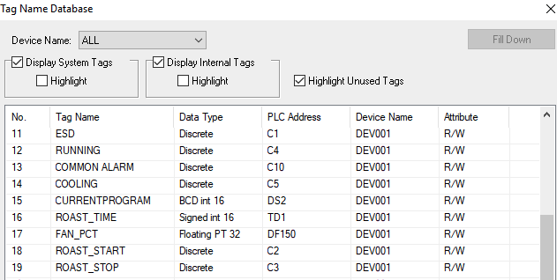

*Figure 32.* Coffee roast viewed through the PID Monitor tool

Tags create the link between the HMI displays and PLC registers. HMI screens are comprised of multiple objects that contain properties, methods, and events, similar to other programming constructs. As an example, clicking on a button control during editing brings up the properties section and allows the user to assign a tag to the button, defines how the button should respond when pressed, and how it should look when pressed. This is illustrated in Figure 33 for the roasting start button. Of note, the tag name selected (ROAST_START) corresponds to the PLC address of C2. Therefore, while the button is depressed on the HMI screen, register C2 in the PLC is enabled, which starts the roaster timer in the roast program and begins the temperature ramp process.

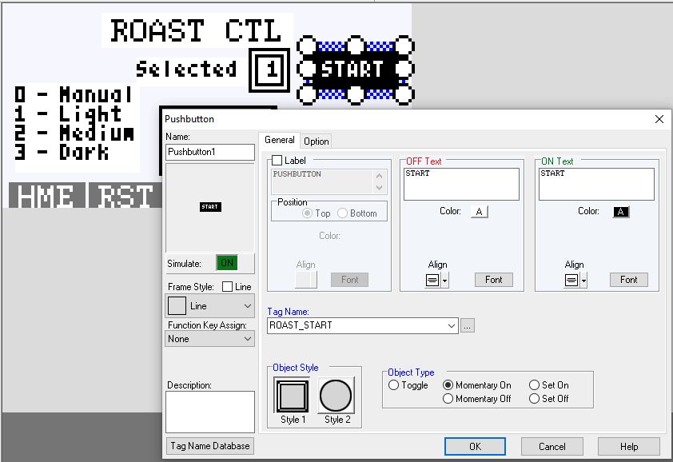

Figure 33. HMI object configuration screen

With the tag database complete, the next task was to develop the screens as per the interface workflow definition. This work is often iterative as some functionality may exist but needs better logical flow, or perhaps only some of the information is included in the tag database, and other tags are required. Nevertheless, Figure 34 showed the main screens used in the roast program and were captured using the C-more software simulation tool.

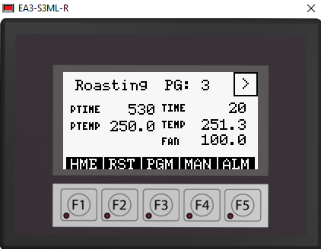 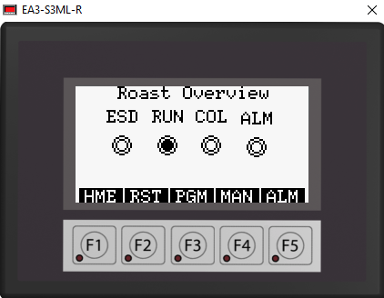

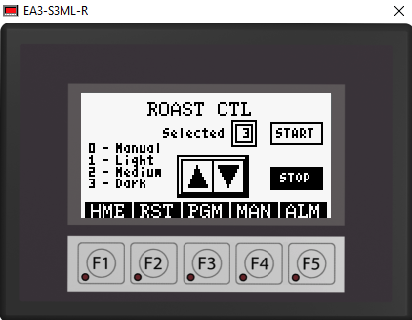 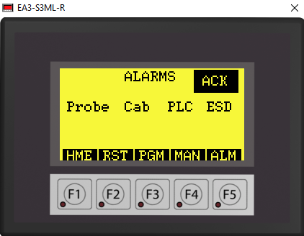

*Figure 34.* HMI screens used for the roast program

# Networking and Security

The final touches to the project included remote access capability for troubleshooting, configuration, and remote monitor and control. For cost and size considerations, a Raspberry PI was chosen to act as wireless to wired network bridge. Specifically, the CanaKit Raspberry Pi 4 4GB Starter Kit was purchased and installed. The Raspberry PI was configured to use the local gigabit Ethernet port to sniff traffic and a USB 3.0 Ethernet adapter for connectivity to the MOXA firewall. The components were connected, as shown in Figure 35.

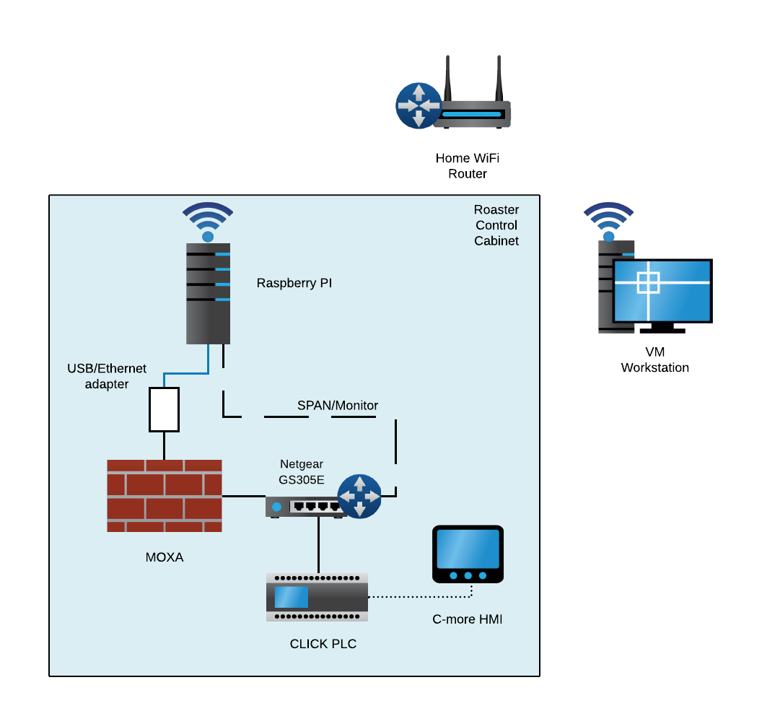

*Figure 35.* Control panel network layout

Configuration for the wired to wireless bridge option was performed by following Raspberry PI 4 WiFi to Ethernet bridge guide (Haley, 2020). With the bridge functioning, the next step was to set up the PI to act as a network sensor. An excellent resource was found by following a recent article by Active Countermeasures (Stearns, 2020). The Raspberry PI is currently configured with this method, but a future endeavor is to perform partial traffic analysis on the local Raspberry PI and metadata to a remote server for further analysis. Finally, the Moxa firewall was configured as least privilege and only allowed UDP traffic from the CLICK PLC VM. At the time of writing, no external Modbus TCP, CIP, or MQTT traffic was flowing from the PLC but is on the roadmap for a future integration project with a remote HMI.

# Conclusion

As ICS security professionals, it is essential to continuously learn new technologies and bridge into other automation and security disciplines. Similarly, it is also important to apply knowledge gained from SANS courses and on the job training. Using components, such as the CLICK PLC and C-more HMI from the ICS612 course, provide an excellent starting point to develop solutions for home projects and labs. The example shared for building out a home coffee roaster is a great opportunity to learn PLC Ladder Logic, automation wiring, networking, security monitoring, and overall engineering. Applied knowledge with a reward of home roasting and the wonderful smells that follow are well worth the effort involved. Home automation projects do come with a time and materials price, so it is vital to research components and develop a project plan before starting down the path of procuring and developing out the solution. No matter what path is chosen, it is important to keep curious, continue learning, and share with the ICS community on the latest DIY ICS Security and Automation projects that are percolating.

# References

Cooper, A. (n.d.). *The Anatomy of a Roast Profile*. Retrieved May 2020, from Cafe Culture: https://www.cafeculture.com/news/the-anatomy-of-a-roast-profile

Haley, W. (2020, May 31). *Raspberry Pi 4 Model B WiFi Ethernet Bridge*. Retrieved July 2020, from willhaley.com: https://willhaley.com/blog/raspberry-pi-wifi-ethernet-bridge/

Home Roasting Supplies. (n.d.). *SR540 Coffee Roaster*. Retrieved May 2020, from Home Roasting Supplies: https://homeroastingsupplies.com/shop/ols/products/sr540-coffee-roaster

Scott, A. (2020). *Learning RSLogix 5000 Programming* (2nd Edition ed.). Birmingham, UK: Packt Publishing. Retrieved from Amazon: https://www.amazon.com/gp/product/B0855XML79/ref=dbs_a_def_rwt_bibl_vppi_i1

Stearns, B. (2020, January 28). *How to use a Raspberry Pi as a network sensor.* Retrieved July 2020, from Active Countermeasures: https://activecountermeasures.com/raspberry_pi_sensor/How%20to%20use%20a%20Raspberry%20Pi%20as%20a%20network%20sensor.pdf

# Appendices

Below are helpful links for the development of the coffee roaster project and suggestions on where to purchase green coffee.

CLICK PLC and C-more HMI device configurations for this project:

* <https://github.com/Eirene77/ICSDIYProject>

C-more micro programming software:

* <https://www.automationdirect.com/support/software-downloads?itemcode=C-more%20Micro>

CLICK PLC programming software:

* <https://www.automationdirect.com/support/software-downloads?itemcode=CLICK>

SANS ICS612 course:

* <https://www.sans.org/cyber-security-courses/ics-cyber-security-in-depth/>

Active Countermeasures: How to use a Raspberry Pi as a Network Sensor - Bill Stearns

* <https://www.youtube.com/watch?v=vja_H59fh1I&feature=youtu.be>

CanaKit Raspberry Pi 4 8GB Starter MAX Kit - 64GB Edition (8GB RAM)

* <https://www.amazon.com/CanaKit-Raspberry-4GB-Starter-MAX/dp/B08956P7LC?ref_=ast_sto_dp&th=1>

Green coffee source:

* <https://www.sweetmarias.com/>

The left image of Figure 1 shows the completed the control cabinet wired to the SR540 roaster. The image on the right shows the completed subpanel wiring and all networking components installed.

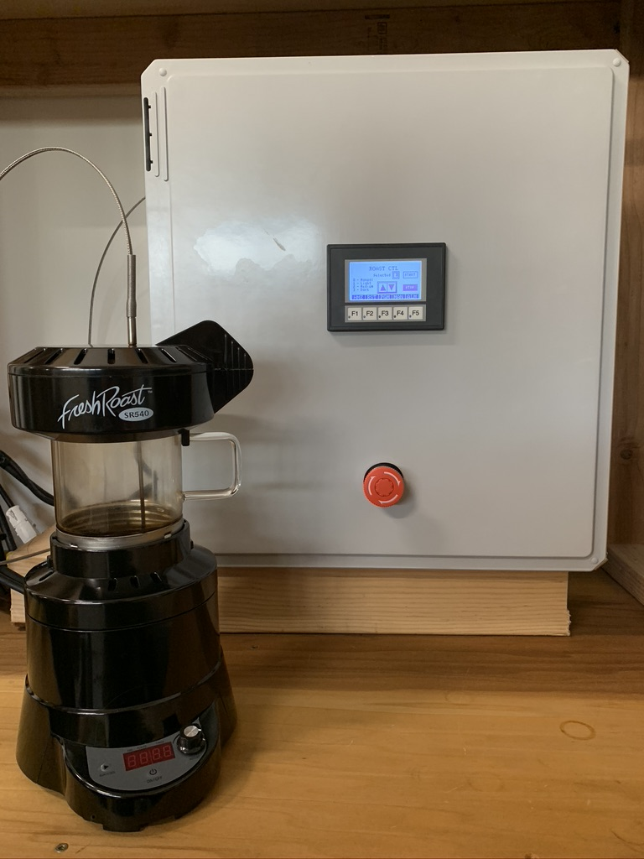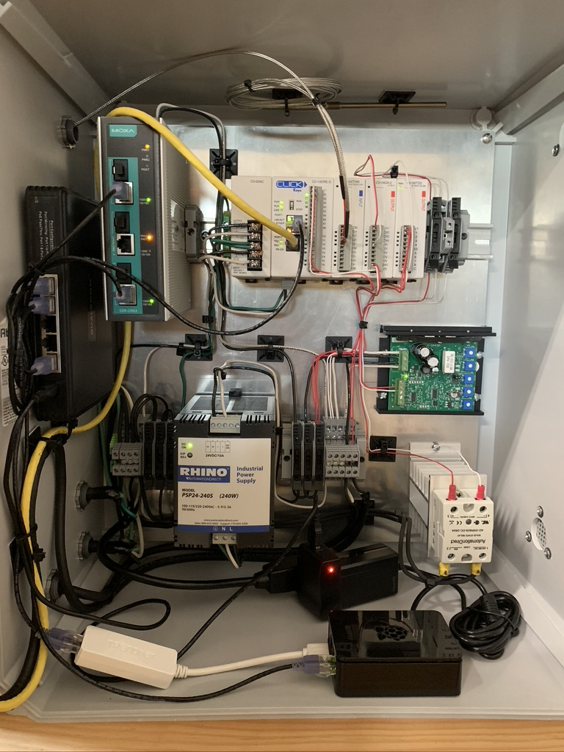 *Figure 1.* Finished Coffee Roaster DIY Project

Figure 2 below shows the competed coffee roaster wiring diagram.

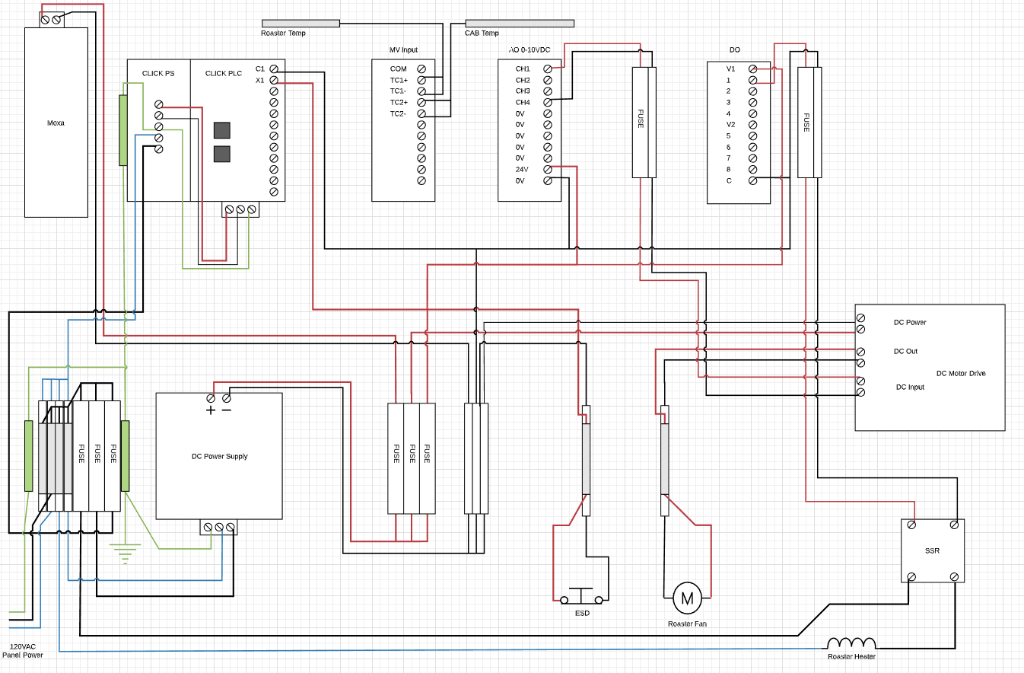

*Figure 2.* Wiring diagram for the roaster control cabinet

Table 1 provides the Bill of Materials (BOM) used to build the DIY roaster project. Smaller items, such as zip ties, screws, and electrical installation tools and materials are not included.

|  |  |  |  |  |
| --- | --- | --- | --- | --- |
| DIY Coffee Roaster BOM |  |  |  |  |
| Note: prices are in USD and estimates only |  |  |  |  |
| Item Code | **Qty** | **Description** | **Price** | **Total** |
| DN-R35SAL1-2 | 1 | DIN rail, slotted, 35mm, 10mm height, 1m length, aluminum. Package of 2. | $ 8.50 | $ 8.50 |
| C0-04DA-2 | 1 | CLICK analog output module, 4-channel, voltage, 12-bit, output voltage signal range(s) of 0-10 VDC, external 24 VDC required. | $ 129.00 | $ 129.00 |
| GSD1-48-10C | 1 | IronHorse GSD1 series DC full-featured drive, 12-48 VDC, 1-phase, 1/50 to 1/8hp at 12 VDC and 1/12 to 1/2hp at 48 VDC, 10A, open frame, panel mount, field-install reverse, potentiometer input, PWM output. | $ 140.00 | $ 140.00 |
| AR30V0R-01RZC | 1 | Fuji Electric emergency stop pushbutton, 30mm, twist-to-release, (1) NC. contact(s), plastic base, metal bezel, Operator: red, mushroom, 40mm, round, plastic. | $ 33.00 | $ 33.00 |
| FR181610HPL | 1 | AttaBox Freedom series enclosure, NEMA 1/3/3S/4X/12/13, 18 x 16 x 10in (HxWxD), wall mount, fiberglass reinforced polyester, gray, crowned single-door, (2) quick-release latches, padlock hasp and staple. | $ 168.00 | $ 168.00 |
| BP1816A | 1 | AttaBox subpanel, 3003H14 aluminum. For use with 18x16 (HxW) FRx181610xx Freedom series and Mx1816xx & WH-M1816Hxx MachoBox series enclosures. | $ 25.00 | $ 25.00 |
| SJOOW-12-3BK-1  Length : 30 | 1 | Southwire flexible portable cord, Type SJOOW, 300V, 3 conductors (includes ground), 12 AWG, EPDM thermoset rubber conductor insulation material, black, white and green, CPE thermoset rubber jacket, black, cut to length. | $ 22.50 | $ 22.50 |
| VENT-2-P10 | 2 | Integra outdoor labyrinth vent, polypropylene, for polycarbonate enclosures. Mounting hardware included. | $ 10.25 | $ 20.50 |
| C0-08TD2 | 1 | CLICK discrete output module, 8-point, 12-24 VDC, sourcing, 1 isolated common(s), 8 point(s) per common, 0.3A/point. Removable terminal block included. | $ 37.00 | $ 37.00 |
| DN-F10MN | 1 | DINnector screw fuse terminal block, accepts wire size 24-10 AWG, gray, 15A, 300V rated (UL), 35mm DIN rail mount, 100kA SCCR. Package of 10. For use with GMA, GMC, S500 and S506 series fuses. | $ 26.50 | $ 26.50 |
| KN-D10GRY-25 | 1 | Konnect-It screw double-level feedthrough terminal block, accepts wire size 26-10 AWG, gray, 30A, 300V rated (UL), 35mm DIN rail mount, 100kA SCCR. Package of 25. For use with jumpers KN-2J10, KN-3J10, KN-4J10 and KN-10J10. | $ 25.00 | $ 25.00 |
| KN-ECDGRY | 1 | Konnect-It terminal block end cover, gray. Package of 25. For use with KN-D10 or KN-D12 series terminal blocks. | $ 8.50 | $ 8.50 |
| KN-10J10 | 1 | Konnect-It terminal block jumper, screw-down type, 10-pole, 32A, 750V. Package of 5. For use with KN-T10 or KN-D10 series block. | $ 10.00 | $ 10.00 |
| S506-25-R | 1 | Bussmann fuse, S506 series, small dimension, time-delay, 0.25A, 250 VAC, glass tube. Package of 5. Supplemental, electronic protection applications. Manufacturer part number: S506-250-R. | $ 9.25 | $ 9.25 |
| S5061-R | 1 | Bussmann fuse, S506 series, small dimension, time-delay, 1A, 250 VAC, glass tube. Package of 5. Supplemental, electronic protection applications. Manufacturer part number: S506-1-R. | $ 9.25 | $ 9.25 |
| GMC10 | 1 | Bussmann fuse, GMC series, small dimension, medium time-delay, 10A, 125 VAC, glass tube. Package of 5. Supplemental, electronic protection applications. Manufacturer part number: GMC-10A-R. | $ 6.00 | $ 6.00 |
| SJOOW-16-2BK-1  Length : 40 | 1 | Southwire flexible portable cord, Type SJOOW, 300V, 2 conductors, 16 AWG, EPDM thermoset rubber conductor insulation material, black and white, CPE thermoset rubber jacket, black, cut to length. | $ 13.60 | $ 13.60 |
| AD-SSR625-DC-280A | 1 | Solid state relay, panel mount, finger-safe hockey puck, 3-32 VDC input voltage, SPST, NO. SCR, 25A contact rating, 24-280 VAC load voltage, zero cross, screw terminal(s), LED indicator(s). Thermal mounting pad included. | $ 18.50 | $ 18.50 |
| KN-EB7-10 | 1 | Konnect-It screw-down end bracket, 10mm wide. Package of 10. For use with 35mm DIN rail. | $ 6.50 | $ 6.50 |
| THMK-T06L06-01 | 1 | ProSense temperature sensor, Type K thermocouple, lead wire transition probe, ungrounded, 6in insertion length, 1/8in probe diameter, stainless steel sheath, 6ft 20 AWG wire leads. | $ 32.50 | $ 32.50 |
| GMA15 | 1 | Bussmann fuse, GMA series, small dimension, fast-acting, 15A, 125 VAC, glass tube. Package of 5. Supplemental, electronic protection applications. Manufacturer part number: GMA-15A-R. | $ 3.75 | $ 3.75 |
| PSP24-240S | 1 | RHINO switching power supply, 24 VDC (adjustable) output, 10A, 240W, 120/240 VAC nominal input, 1-phase, enclosed, plastic housing, IP20, 35mm DIN rail or panel mount, removable screw terminal. DIN rail inserts for panel mounting included. | $ 190.00 | $ 190.00 |
|  |  | **Non-Automation Direct** |  |  |
| SR540 | 1 | Coffee Roaster  https://homeroastingsupplies.com/shop/ols/products/sr540-coffee-roaster | $ 189.00 | $ 189.00 |
| ALR LPCG50 | 4 | 1/2 Strain Relief cord grip |  | $ 7.72 |
| CA-HEATSINKW | 1 | *Twidec/Single-Phase Solid-State Relay Aluminum Heat Sink* |  | $ 14.99 |
| BOM Total | **$1,154.56** |  |  |  |

*Table 1.* ICS DIY project BOM